**CSE3505 - FOUNDATION OF DATA ANALYTICS**

**J COMPONENT - PROJECT REPORT**

**HARMONY AI**

**EMOTION-AWARE CONVERSATIONAL MEDIATOR FOR RELATIONSHIP SUPPORT**

***By***

**YUVALAKSHMI M**

**22MIA1040**

**MTech CSE with Specialization**

***Under the Guidance of***

**Dr. R. JOTHI**

**(E1 slot)**



**School of Computer Science and Engineering**

**VIT Chennai**

**Vandalur - Kelambakkam Road, Chennai - 600 127**

# Table of Contents

| **S.No** | **Content** |
| --- | --- |
| 1 | Abstract |
| 2 | Introduction |
| 3 | Problem Definition & Objectives |
| 4 | Dataset & Preprocessing |
| 5 | Methodology / Algorithms Used |
| 6 | Implementation Details |
| 7. | Pipeline Architecture |
| 8 | Results & Discussion |
| 9 | Novelty: Blend Recommendation System |
| 10 | Conclusion & Future Work |
| 11 | References |

# 1. Abstract

Harmony AI is a comprehensive web-based emotional mediation system designed to help individuals and couples understand, reflect on, and navigate their emotional experiences. The system combines machine learning, natural language processing, cloud storage, and modern web technologies to provide an intelligent, empathetic, and interactive emotional-support environment.

At its core, Harmony AI employs a Bi-LSTM (Bidirectional Long Short-Term Memory) model trained on the ISEAR dataset to classify emotions from user-entered text. The input text undergoes extensive preprocessing, including tokenization, stopword removal, stemming, and TF-IDF vectorization, before being passed into the model for emotion prediction. These predictions are then used to craft meaningful recommendations generated through a Large Language Model (LLM), specifically an Ollama-based local LLM for privacy, efficiency, and natural-language quality. The LLM produces actionable, empathetic advice in the form of bullet points, making emotional reflection more structured and user-friendly.

The system is built using a full-stack architecture with a **FastAPI backend**, a **React (Vite) frontend**, and **Firebase Firestore** as the cloud database. Firestore stores each user’s emotional sessions, including text, predicted emotions, and AI-generated recommendations. These sessions are retrieved and displayed in the user’s sidebar as part of a persistent emotional history.

Harmony AI also introduces an innovative feature called **Blend Mode**, where users can search for and connect their partner’s account. When activated, the system fetches emotional histories from both users’ Firestore records and provides a unified emotional interpretation through the LLM. This generates joint relationship insights, enabling couples to better understand each other's emotional patterns, root causes of conflicts, and communication styles.

The system further supports real-time chatting, dark/light themes, voice-based text input, new session creation, and session switching. Overall, Harmony AI integrates advanced models, cloud storage, and user-centered UI design to deliver a functional and emotionally intelligent relationship-support platform.

# 2. Introduction

Emotions play a crucial role in human relationships, influencing how people communicate, behave, and interpret one another’s actions. However, expressing emotions effectively is often challenging. Many individuals struggle to articulate what they feel, and this lack of clarity can lead to misunderstandings, emotional disconnect, and recurring conflicts within relationships. Misinterpretations frequently arise not because partners lack care or love, but because they lack emotional awareness and communication tools.

In modern society where stress, digital communication, and fragmented attention are common emotional miscommunication has become even more prevalent. Couples increasingly rely on textual communication through messages and social platforms, where tone and emotional cues are easily lost. As a result, there is a pressing need for systems that can identify emotional signals from text, help users process their feelings, and facilitate healthier communication habits.

Harmony AI was developed with the primary goal of addressing these challenges. It acts as an **AI-powered emotional mediator** that helps users understand both their own emotions and their partner’s emotional experiences. By combining machine learning, LLM-based reasoning, cloud data storage, and an intuitive chat interface, Harmony AI offers users a safe, private, and intelligent platform to reflect on their emotional states.

The system focuses on this problem because emotional clarity is foundational to relationship stability. Individuals who understand their emotions are better able to communicate, regulate conflicts, and build stronger connections. However, emotional understanding is not always intuitive; it requires tools that can analyze patterns, provide grounded insights, and assist users in interpreting subtle emotional expressions.

Harmony AI leverages a Bi-LSTM emotion classification model for accurate emotion detection from text and a Large Language Model (Ollama) for generating empathetic, actionable advice. It also incorporates a unique Blend Mode, which observes emotional histories from both partners to generate combined relationship insights. This is particularly valuable because emotional issues often involve two people, and understanding both sides together creates more meaningful guidance.

With its combination of intelligent analysis, cloud storage (Firestore), session history tracking, theme customization, and interactive chat interface, Harmony AI aims to bring emotional intelligence to everyday digital communication and promote healthier, more empathetic relationships.

# 3. Problem Definition & Objectives

## ****Problem Definition****

In many relationships, individuals struggle to express emotions clearly. As a result, small misunderstandings escalate into conflicts. There is a need for a tool that:

1. Detects emotional cues accurately
2. Provides empathetic responses
3. Helps partners understand each other
4. Maintains a structured emotional history

## ****Objectives****

The major objectives of the system are:

1. To build an emotion detection model using a deep learning architecture (BiLSTM).
2. To preprocess and vectorize text using NLP techniques.
3. To develop a full-stack application for real-time emotional conversation.
4. To store user sessions securely using Firebase Firestore.
5. To integrate a Large Language Model (LLM) for emotional recommendations.
6. To introduce "Blend Mode" for generating joint relationship insights using partner histories.

# Dataset & Preprocessing

Harmony AI uses the **ISEAR (International Survey on Emotion Antecedents and Reactions)** dataset.

#### Dataset Overview

* **Source**: The dataset is hosted on Hugging Face by the user gsri-18. [Hugging Face](https://huggingface.co/datasets/gsri-18/ISEAR-dataset-complete?utm_source=chatgpt.com)
* **Size**: Approximately 7,520 text samples.
* **Format**: CSV files, compatible with Python libraries like pandas.
* **Emotion Labels**: The dataset includes seven emotion categories: joy, fear, anger, sadness, disgust, shame, and guilt.
* **Content**: Each entry consists of a short text sample and its corresponding emotion label.

#### Accessing the Dataset

You can access the dataset here: [ISEAR-dataset-complete on Hugging Face](https://huggingface.co/datasets/gsri-18/ISEAR-dataset-complete?utm_source=chatgpt.com).

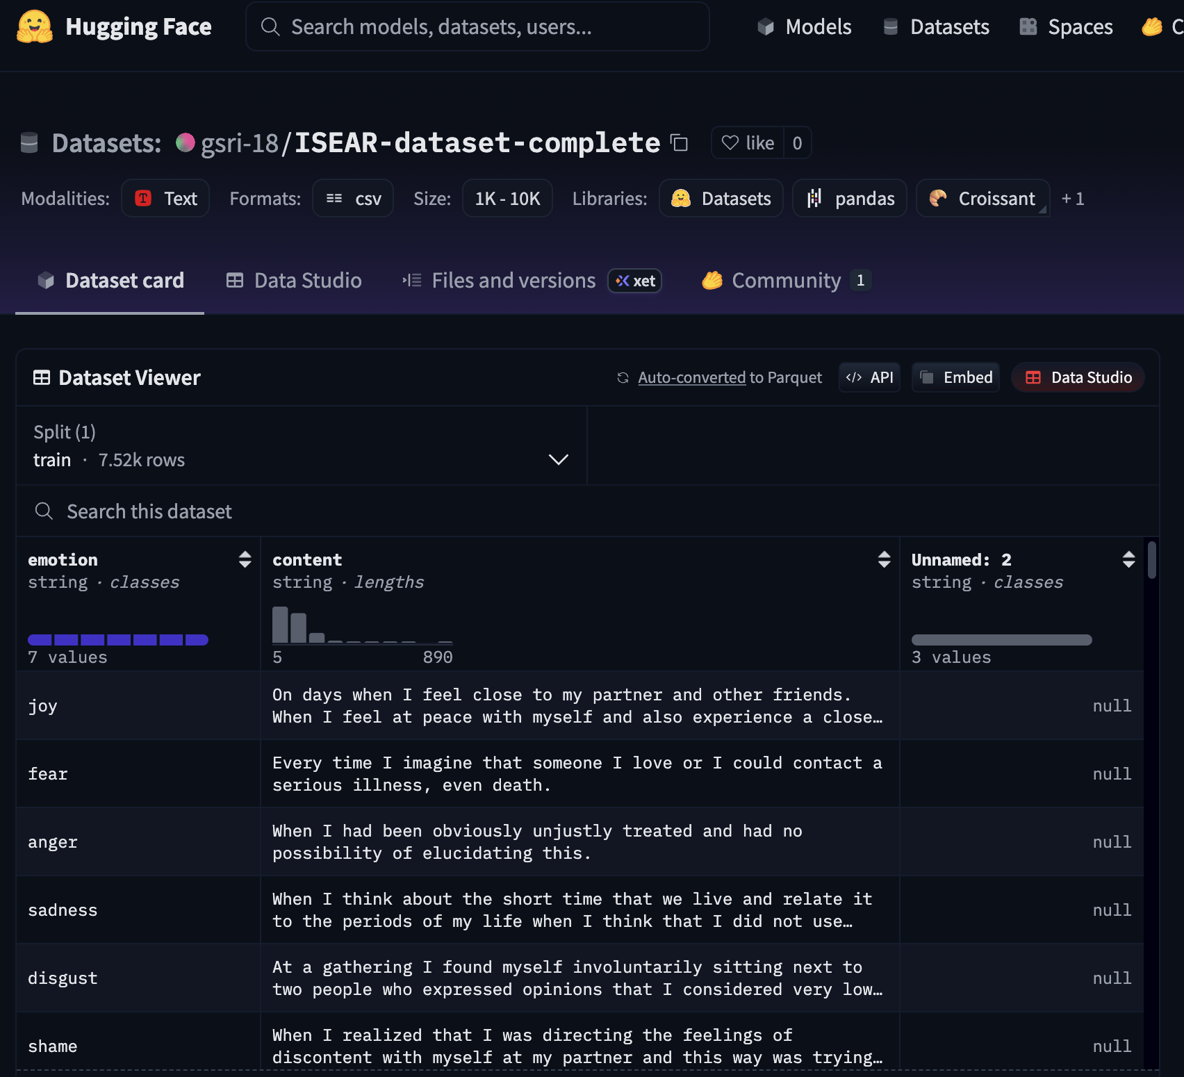

## ****Text Preprocessing Pipeline****

**Text Preprocessing:** The preprocessing steps are:

1. **Lowercase Conversion:** Converts all text to lowercase.
2. **Tokenization & Punctuation Removal:** Splits text into individual words (tokens) and removes all punctuation.
3. **Stopword Removal:** Removes common words (like "the", "a", "is") that don't add emotional meaning.
4. **Stemming:** Reduces words to their root form (e.g., "feeling" $\rightarrow$ "feel").

### Original Data Samples

Here are 2 samples from the ISEAR dataset's train split, showing the emotion label and the raw content text.

#### Sample 1 (joy)

1. Original Text:

"On days when I feel close to my partner and other friends. When I feel at peace with myself and also experience a close contact with people whom I regard greatly."

1. After Lowercasing, Tokenization, & Punctuation Removal:

['on', 'days', 'when', 'i', 'feel', 'close', 'to', 'my', 'partner', 'and', 'other', 'friends', 'when', 'i', 'feel', 'at', 'peace', 'with', 'myself', 'and', 'also', 'experience', 'a', 'close', 'contact', 'with', 'people', 'whom', 'i', 'regard', 'greatly']

1. After Stopword Removal:

['days', 'feel', 'close', 'partner', 'friends', 'feel', 'peace', 'also', 'experience', 'close', 'contact', 'people', 'regard', 'greatly']

1. Final Processed Text (After Stemming):

"day feel close partner friend feel peac also experi close contact peopl regard greatli"

#### Sample 2 (fear)

1. Original Text:

"Every time I imagine that someone I love or I could contact a serious illness, even death."

1. After Lowercasing, Tokenization, & Punctuation Removal:

['every', 'time', 'i', 'imagine', 'that', 'someone', 'i', 'love', 'or', 'i', 'could', 'contact', 'a', 'serious', 'illness', 'even', 'death']

1. After Stopword Removal:

['every', 'time', 'imagine', 'someone', 'love', 'could', 'contact', 'serious', 'illness', 'even', 'death']

1. Final Processed Text (After Stemming):

"everi time imagin someon love could contact seriou ill even death"

Colab Proorocessing:-

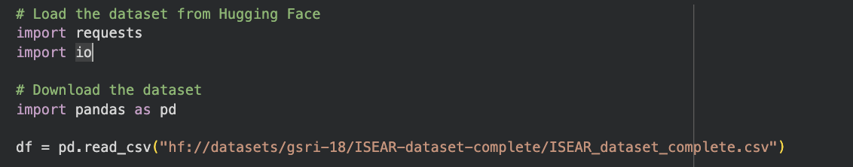

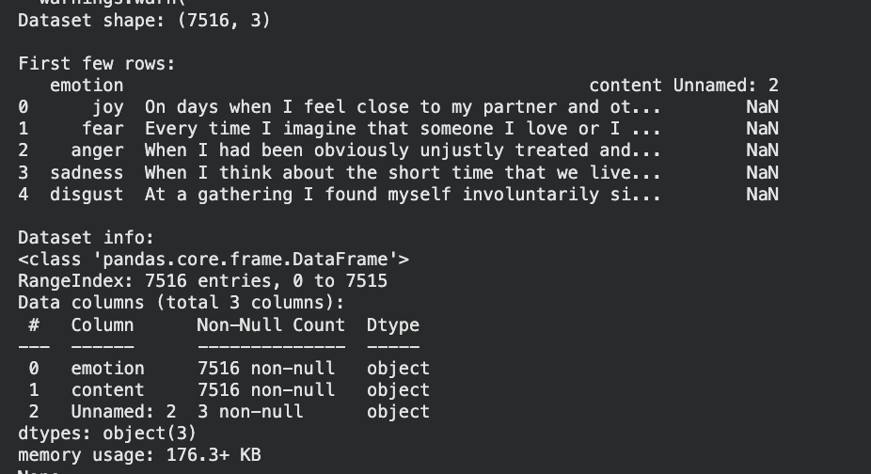

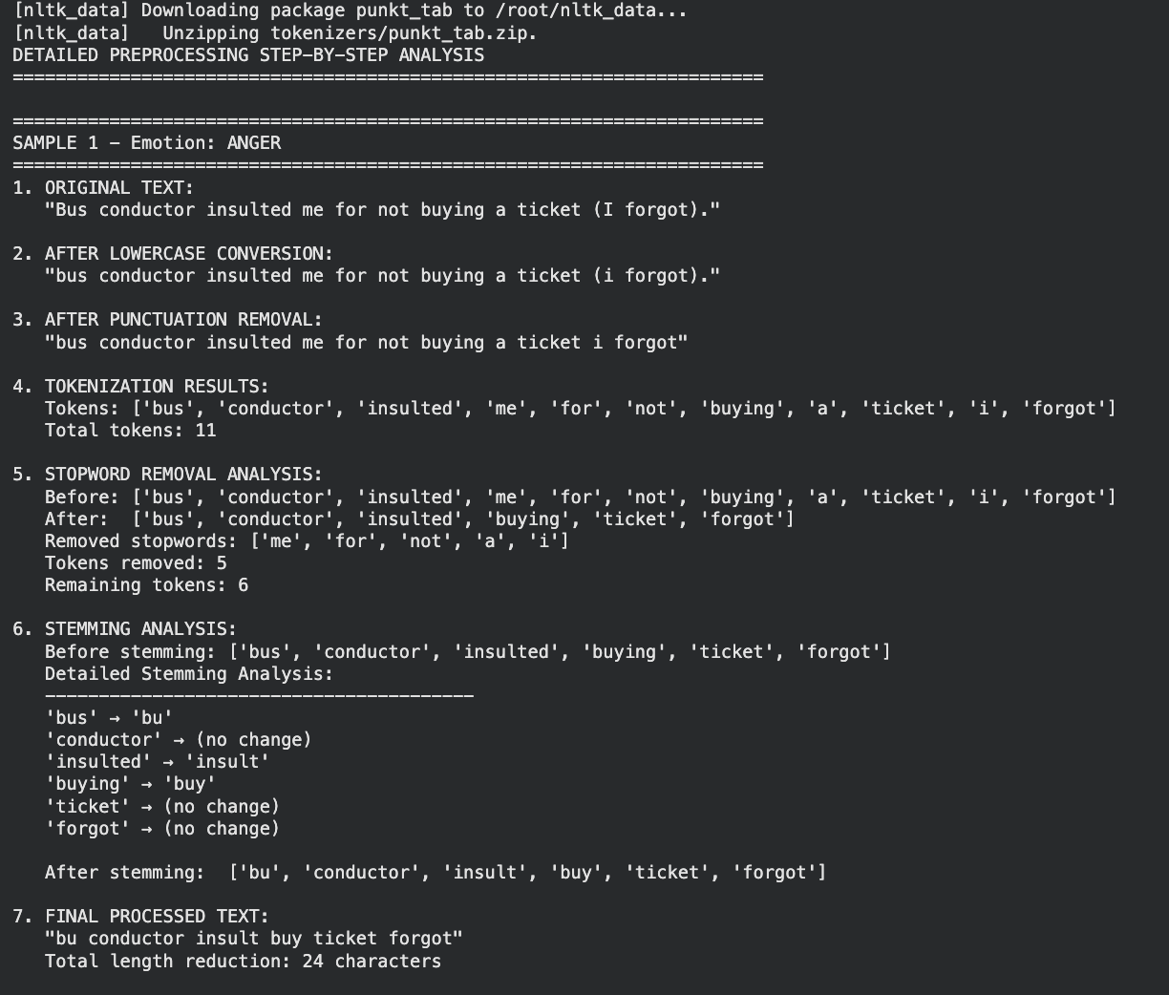

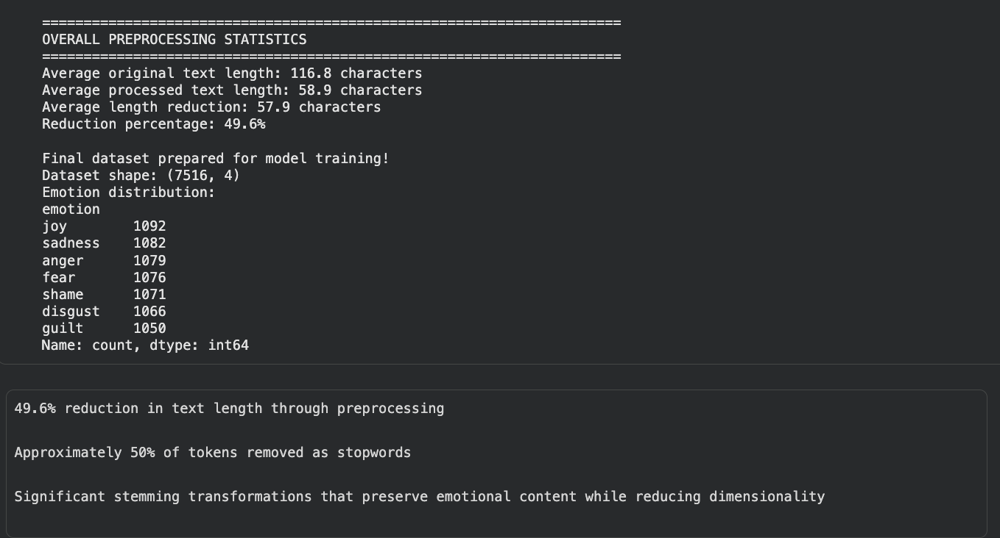

# Methodology / Algorithms Used

**5.1 Feature Extraction: TF-IDF**

TF-IDF converts the cleaned text into numerical vectors.  
Advantages:

Highlights emotion-specific keywords

Reduces noise

**5.2 Classification Model: Bi-LSTM**

Bi-LSTM (Bidirectional Long Short-Term Memory) is the core emotion detection model.

🡺 Processes text in **both directions**

🡺 Captures long-range dependencies

🡺 Learns contextual meaning of emotions

The model receives TF-IDF embeddings and passes them through forward and backward LSTM cells to predict the correct emotion label.

**5.3 Recommendation System: LLM (Ollama)**

Ollama LLM is used to generate:

Empathetic responses

Emotional insights

Partner-based recommendations (in Blend Mode)

🡺 Runs locally on device (no external API cost)

🡺 Faster inference

🡺 Privacy friendly

🡺 High accuracy and natural-language quality

# ****6. IMPLEMENTATION DETAILS****

## ****6.1 Frontend (React + Vite)****

* React used for UI components
* Vite for faster dev environment
* Theme system added (light/dark)
* Chat UI with user & AI bubbles
* Sidebar for session navigation
* Voice-to-text support

## ****6.2 Backend (FastAPI)****

* FastAPI handles:
  + Emotion prediction requests
  + LLM processing
  + Session storage in Firestore
  + Blend Mode processing
* Uvicorn ASGI server used to run backend

### Backend Ports:

* Backend server: **localhost:8000**
* Frontend server: **localhost:5173**
* Ollama LLM server: **localhost:11434**

## ****6.3 Firestore Storage****

User data stored in:

users/

email/

sessions/

session_id/

text

emotion

advice

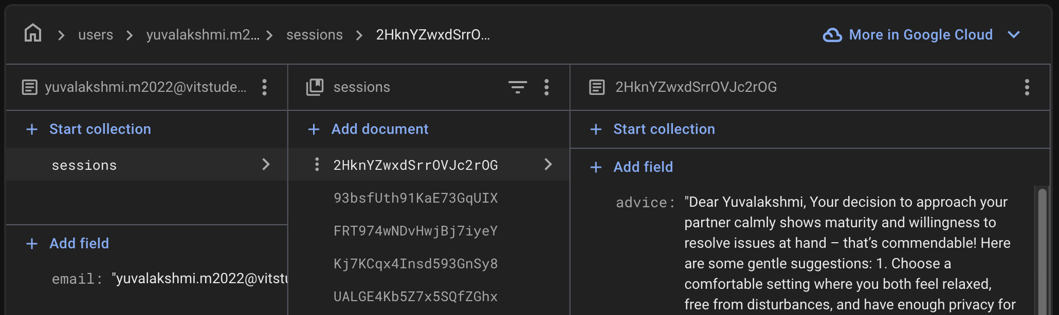

# Pipeline Architecture

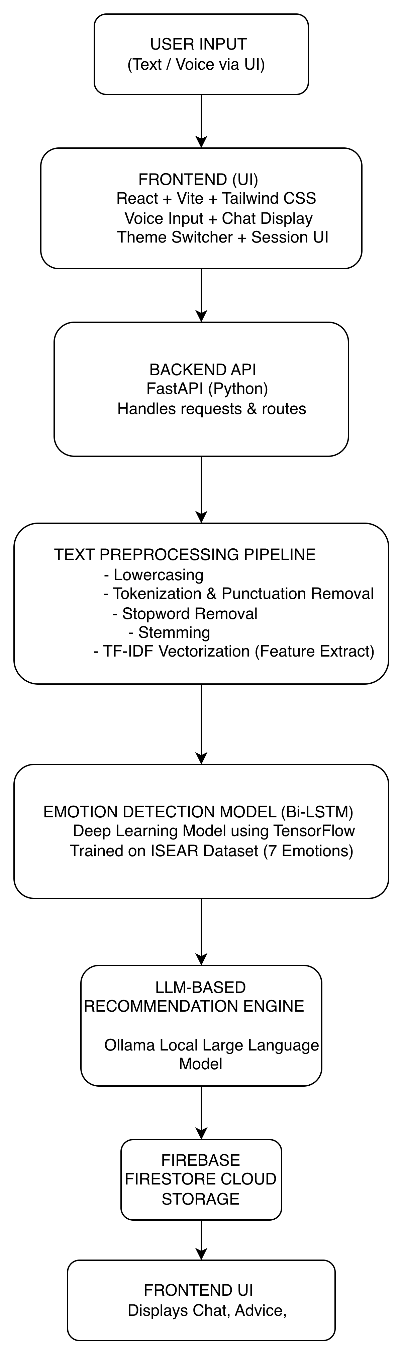

# Results & Discussion

**Result Demo Video :**

[**https://drive.google.com/file/d/1ZlYezGGcr0r82jH6dreK-ATClrmlYEOt/view?usp=sharing**](https://drive.google.com/file/d/1ZlYezGGcr0r82jH6dreK-ATClrmlYEOt/view?usp=sharing)

**Github Repository:** [**https://github.com/Yuvalakshmii/HarmonyAI**](https://github.com/Yuvalakshmii/HarmonyAI)

The Harmony AI application was successfully implemented and tested across all modules, including emotion detection, AI-generated recommendations, session management, theme switching, and the Blend feature. The system accurately classified user emotions using the Bi-LSTM model and generated supportive advice through the integrated LLM. Firestore storage operated reliably, allowing users to view past sessions and partner-linked insights. The final UI was fully functional, responsive, and demonstrated smooth interaction across both frontend and backend components.

## ****Result 1: Backend Server Execution****

The FastAPI backend was successfully launched on **port 8000**, handling emotion analysis, LLM processing, and Firestore communication without errors.

Backend starting in Cursor AI: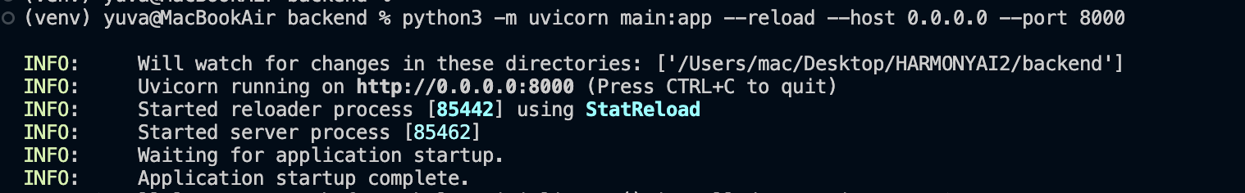

**Google Firestore:**

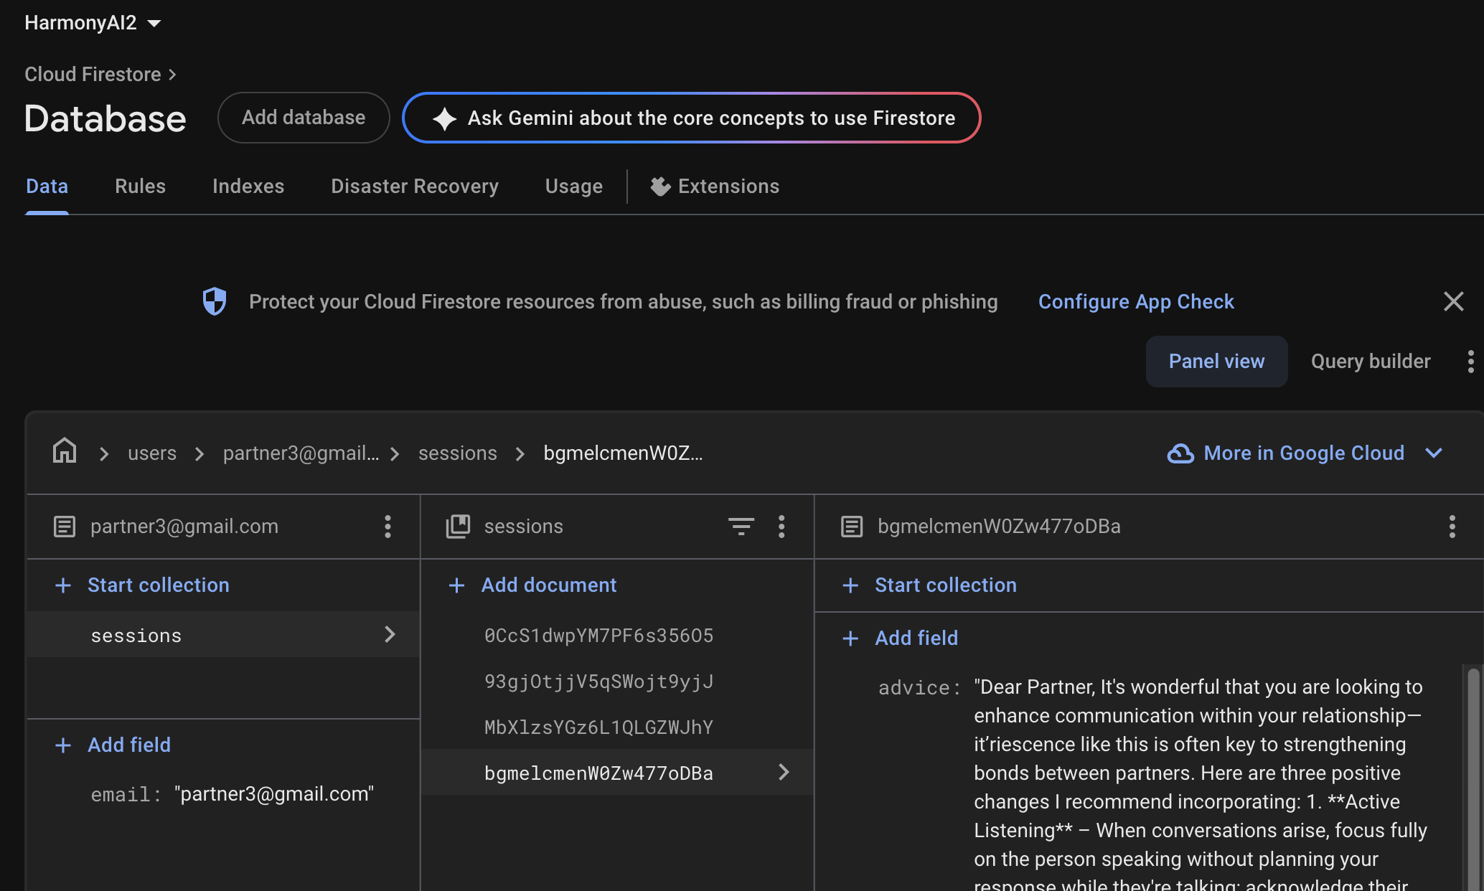

## ****Result 2: LLM Service Running (Ollama)****

The Ollama LLM server operated on **port 11434**, enabling real-time generation of empathetic recommendations and partner blend insights.

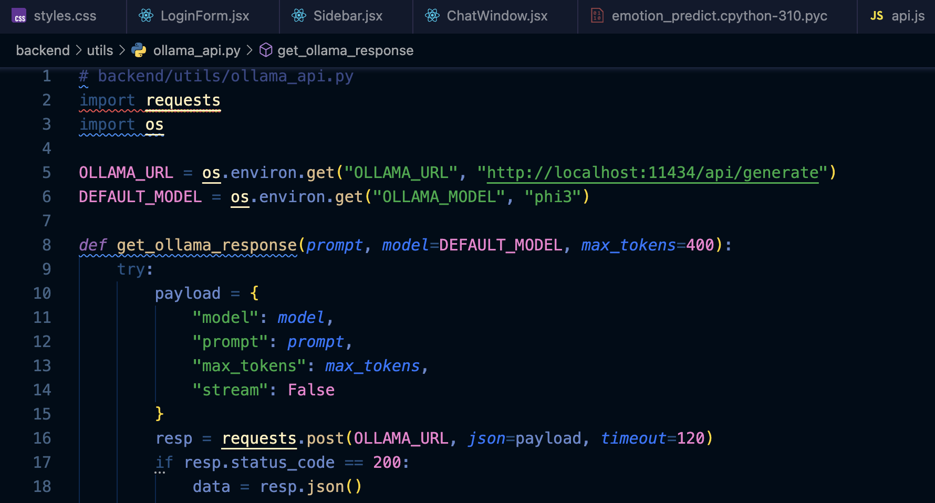

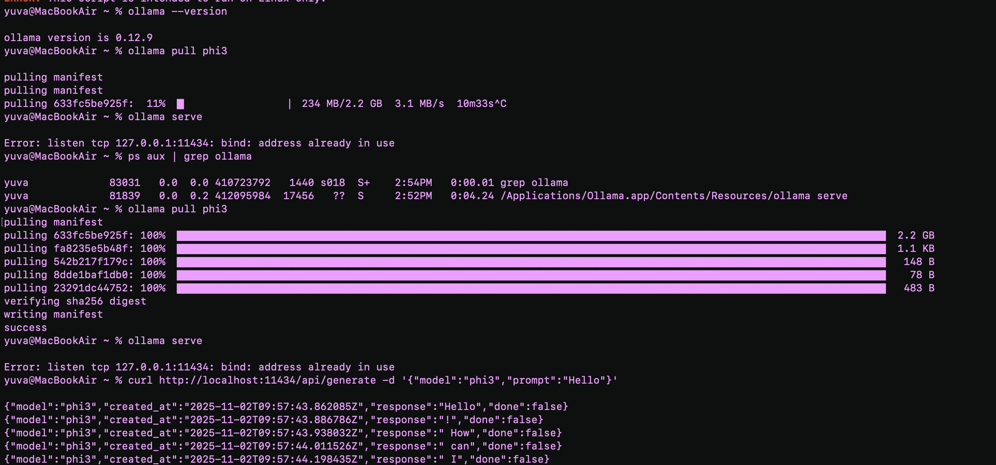

## ****Result 3: Frontend Application Deployment****

The React (Vite) frontend ran smoothly on **port 5173**, providing a responsive and intuitive chat interface connected to the backend.

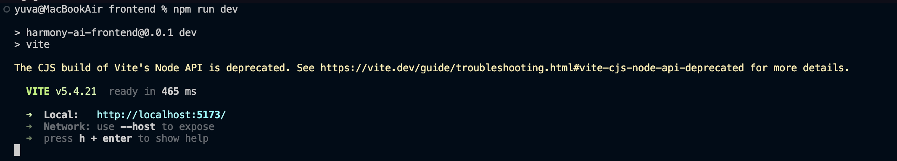

**http://localhost:5173/**

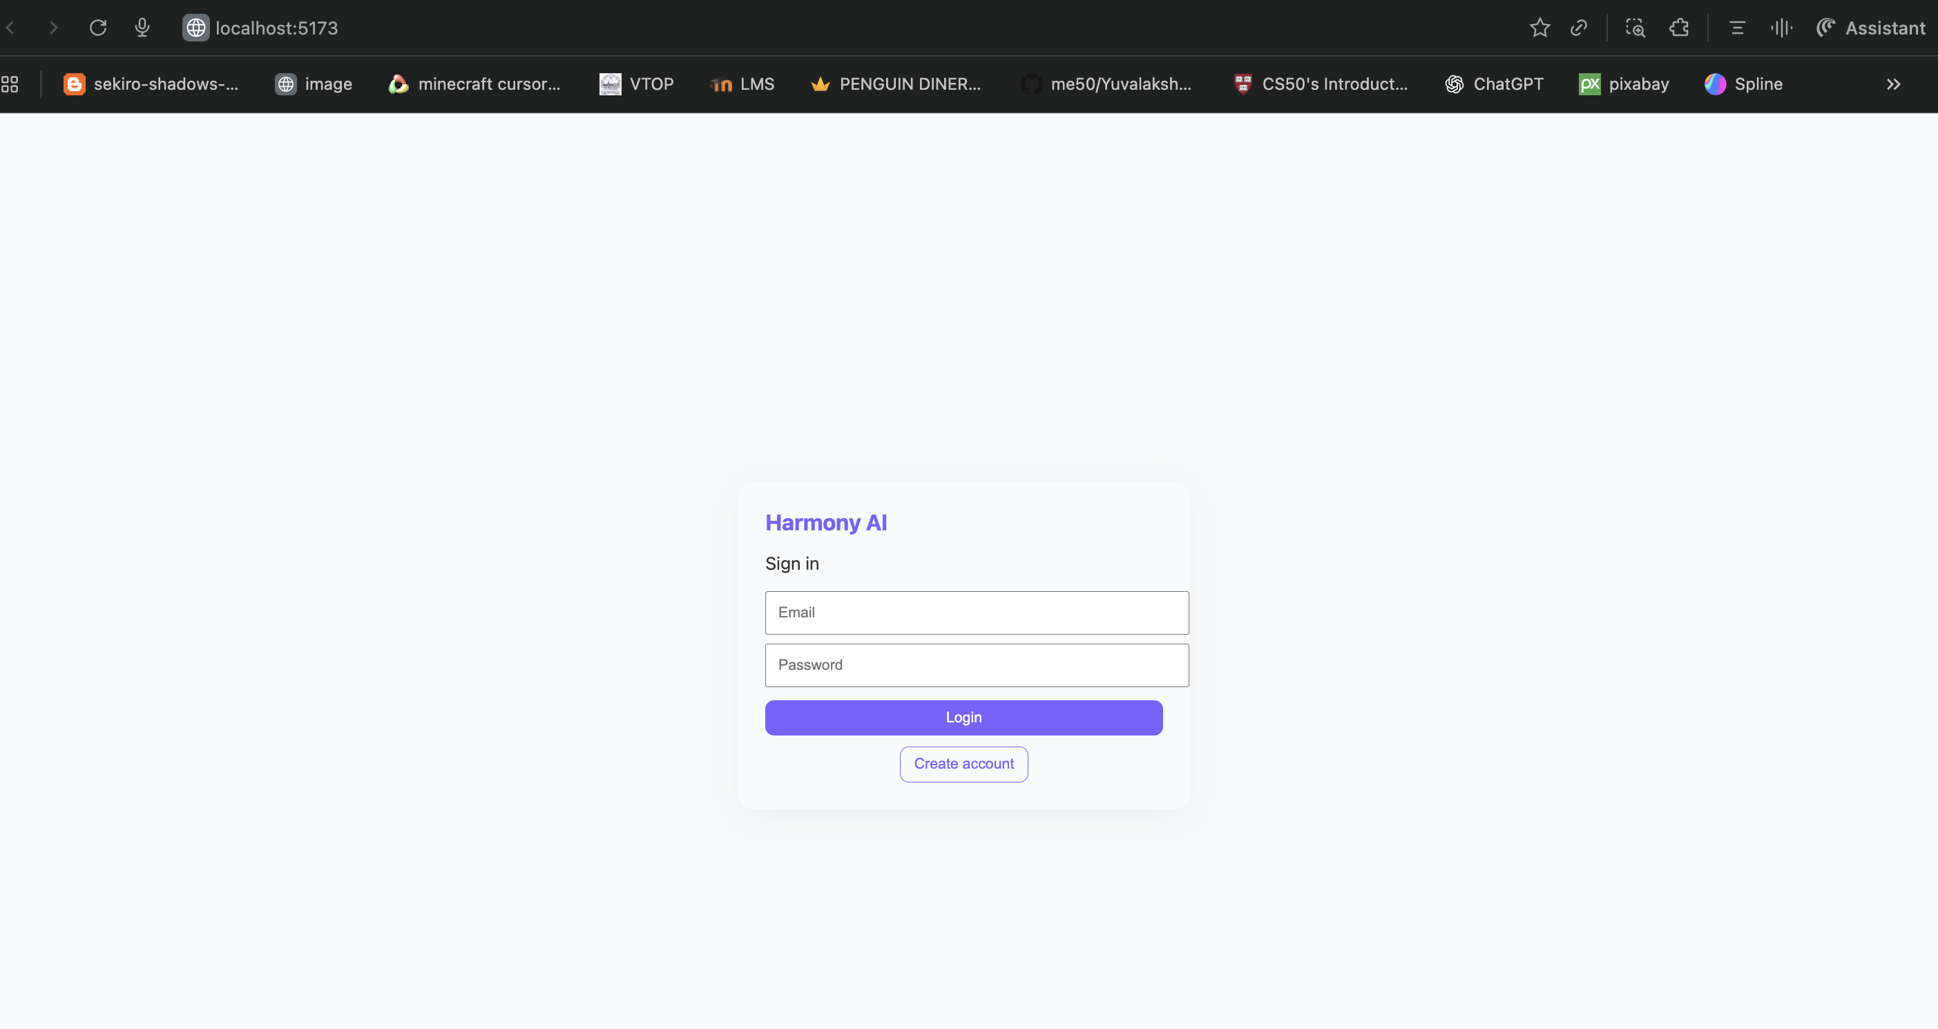

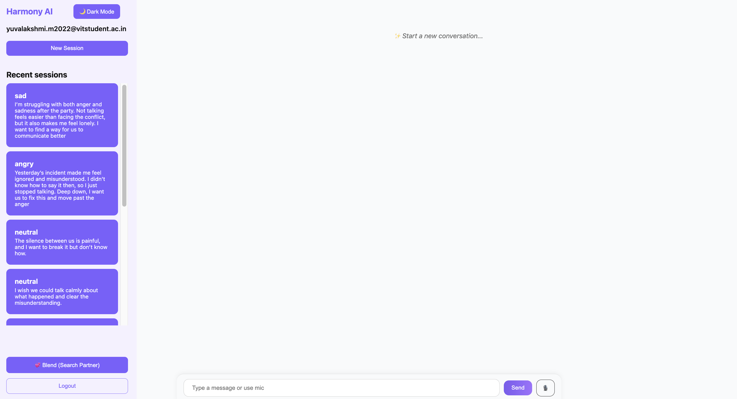

**Recent Session**

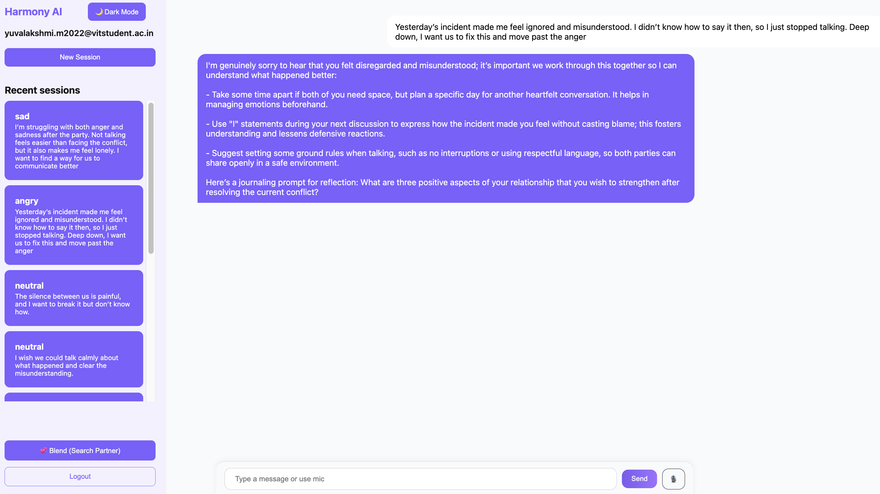

**New Session**

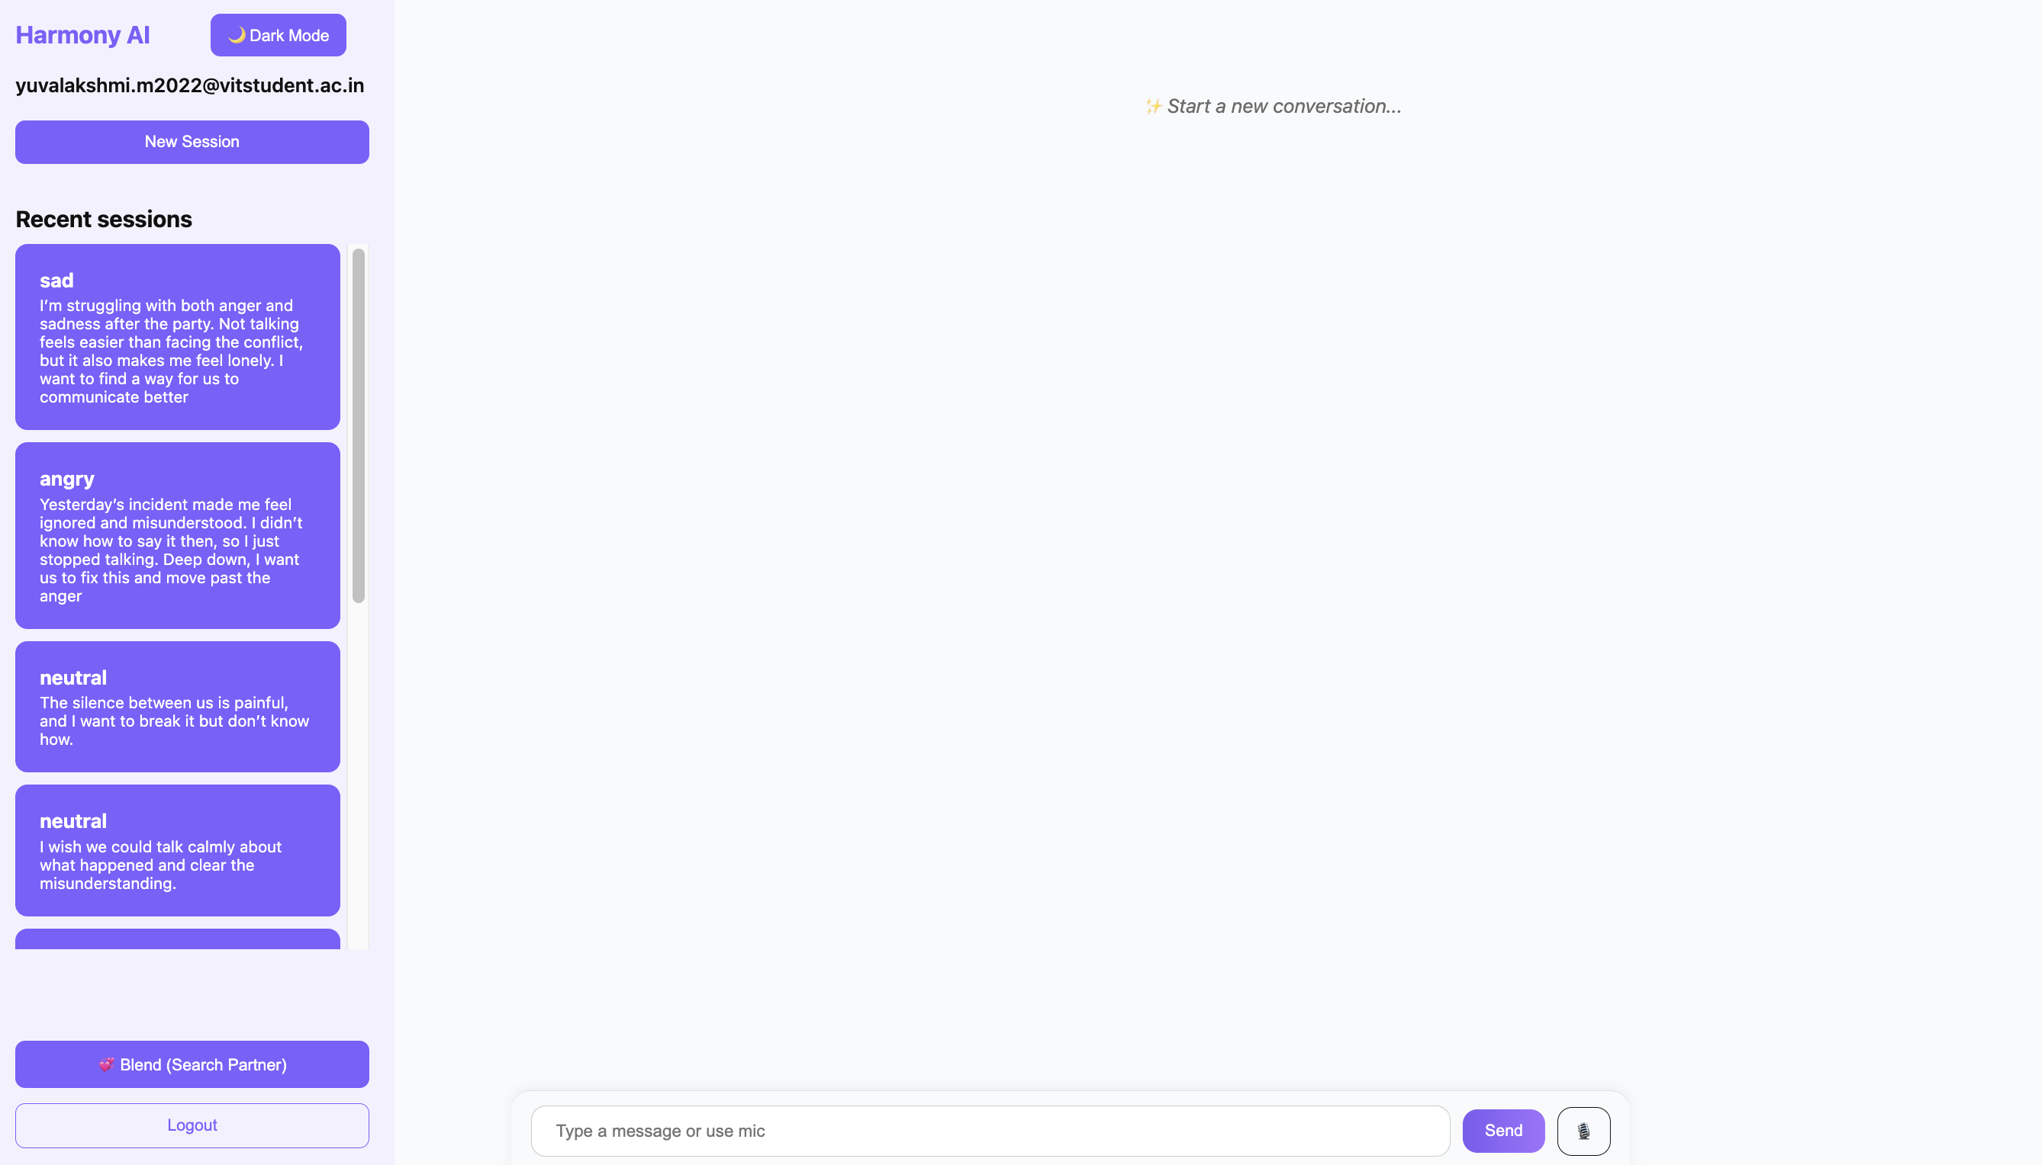

**Dark Theme**

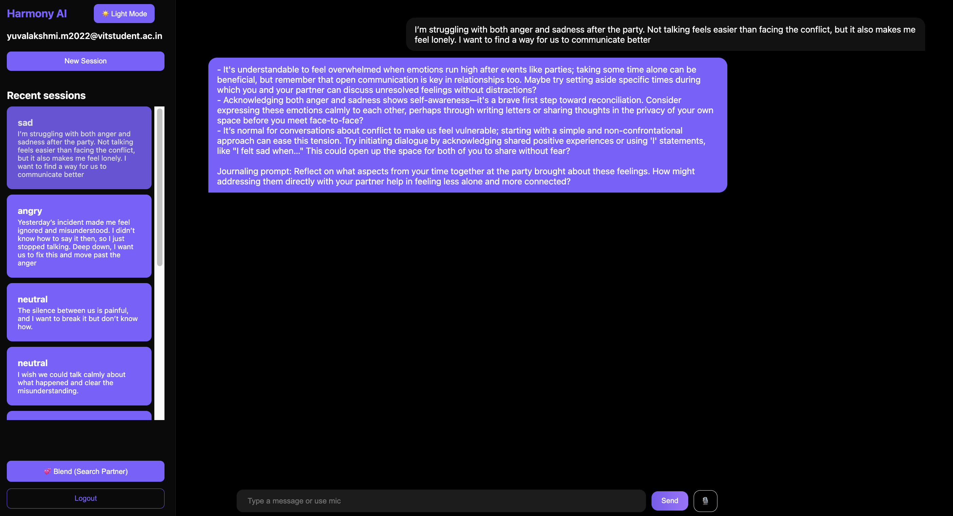

**Click “Blend”**

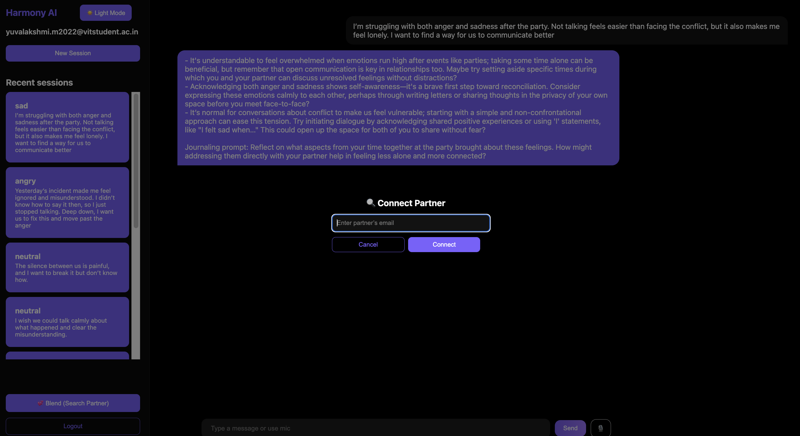

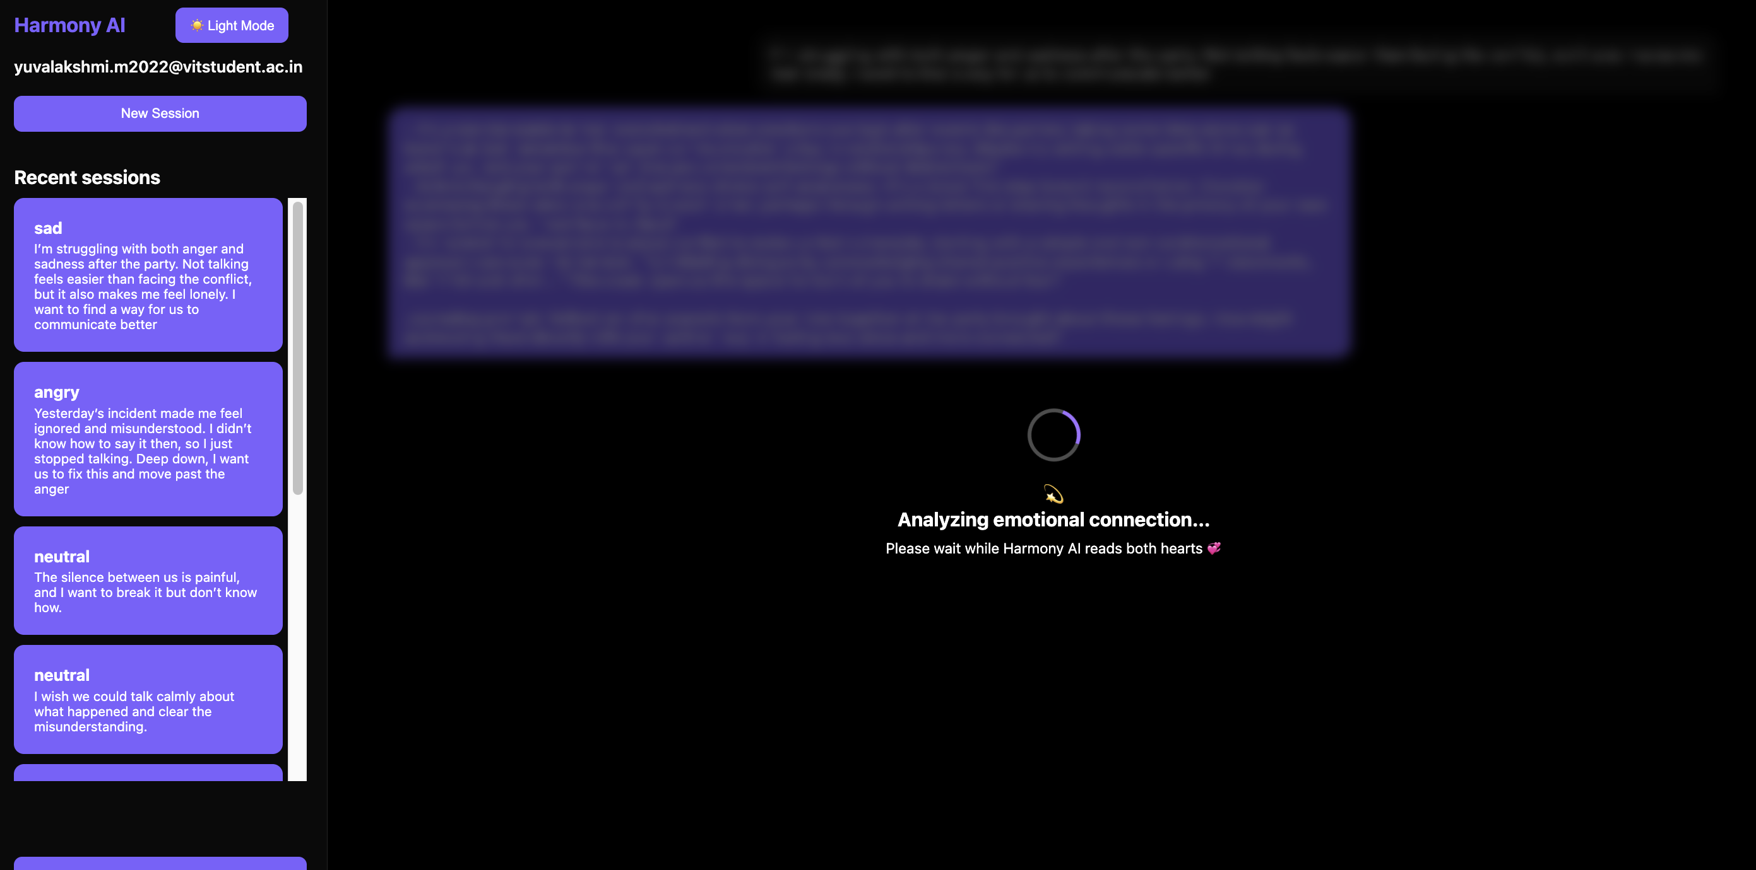

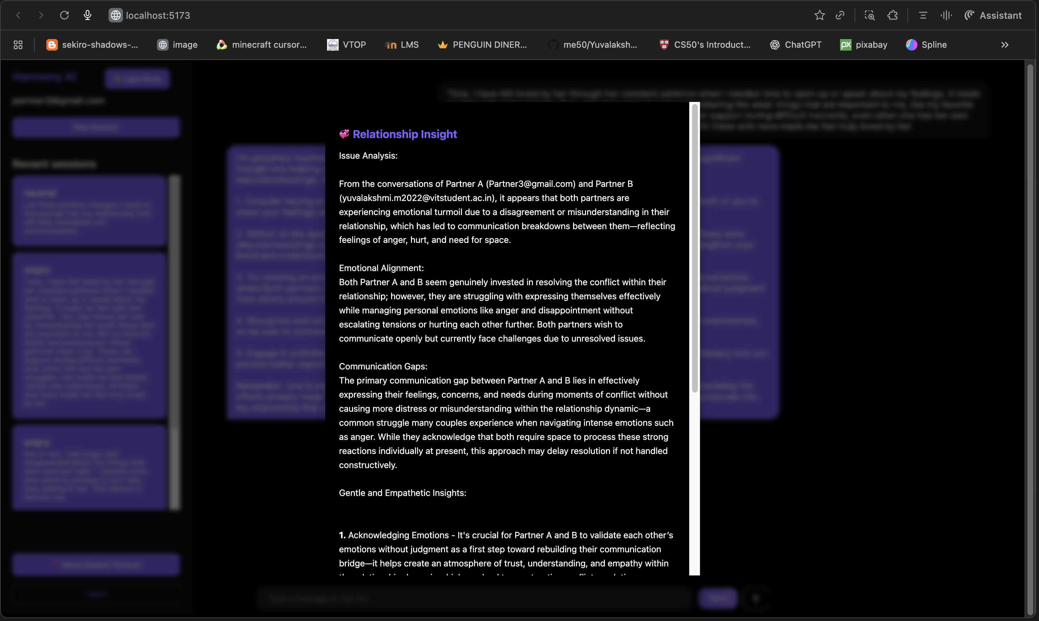

# ****8. NOVELTY: BLEND MODE****

The **Blend** feature is the most innovative part of Harmony AI.

1. User searches and connects with their partner’s account.
2. System fetches emotional history of **both users**.
3. LLM analyzes:

* Each partner’s emotional patterns
* Recent conflicts
* Mood cycles
* Sentiment trends

1. A joint emotional summary is generated.

### Example Output:



This turns Harmony AI from a solo therapy bot into a **relationship intelligence system**.

# ****9. CONCLUSION & FUTURE WORK****

Harmony AI successfully integrates machine learning, natural language processing, and full-stack web development to create an intelligent emotional mediation platform. By combining TF-IDF preprocessing, a Bi-LSTM emotion classification model, and an Ollama-based Large Language Model, the system provides users with meaningful emotional insights and practical relationship guidance. The application maintains session-wise chat histories using Firebase Firestore, supports seamless light/dark themes, voice input, and allows users to initiate new emotional sessions at any time.

A key contribution of this project is the **Blend Mode**, which introduces a novel approach to analyzing relational dynamics. By securely retrieving emotional histories from two user accounts, Harmony AI can generate connected emotional insights that reflect both partners’ perspectives. This provides a more holistic view of emotional patterns and supports healthier communication.

Overall, Harmony AI demonstrates how AI-powered behavioral understanding can be used responsibly to support emotional well-being and strengthen human relationships.

## ****Future Work****

* **Add a secure partner-invite system for Blend Mode**   
  When a user searches for a partner’s email to initiate blending, the system will send the partner a secure invitation.  
  Only if the partner accepts the invite should the Blend feature activate.  
  This ensures privacy, prevents unauthorized account linking, and establishes mutual consent before emotional histories are shared.
* **Add multilingual emotion detection**  
  Extend the Bi-LSTM model and pre processing pipeline to support multiple languages for global accessibility.
* **Add couple-based emotional progress tracking**  
  Provide weekly emotional summaries, compatibility trends, and communication insights.

### 10. References

[1] Alfarizi, M.I., Syafaah, L., & Lestandy, M. (2022). Emotional Text Classification Using TF-IDF (Term Frequency-Inverse Document Frequency) And LSTM (Long Short-Term Memory). *JUITA: Jurnal Informatika*. [[CrossRef](https://doi.org/10.30595/juita.v10i2.13262)]

[2] D. Haryadi and G. P. Kusuma, "Emotion Detection in Text using Nested Long Short-Term Memory," Int. J. Adv. Comput. Sci. Appl., vol. 10, no. 6, pp. 108–118, 2019. [[CrossRef](https://thesai.org/Publications/ViewPaper?Code=IJACSA&Issue=6&SerialNo=45&Volume=10)]

[3] S. A. Khan, A. Hussain, and M. Iqbal, "LSTM, VADER and TF-IDF based Hybrid Sentiment Analysis Model," International Journal of Advanced Computer Science and Applications (IJACSA), vol. 12, no. 7, pp. 108–118, 2021. [[CrossRef](https://thesai.org/Publications/ViewPaper?Volume=12&Issue=7&Code=IJACSA&SerialNo=30)]

[4] R. Darbar and V. Nagda, "Bi-LSTM Model for Emotion Recognition in Text," *Int. J. Comput. Technol.*, vol. 12, no. 4, pp. 26–36, Jul.–Aug. 2025. [[CrossRef](https://ijctjournal.org/bilstm-emotion-recognition-model/?utm_source=chatgpt.com)]